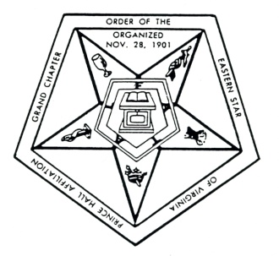
Grand Chapter

Order of Eastern Star of Virginia

Prince Hall Affiliation

DISPENSATION REQUEST

DATE___________________

From: Worthy Matron ________________________Chapter ____________________No. _____

To: Grand Deputy Organizer ______________________________District No. ______________

A dispensation is requested for the following:

To change the stated meeting date

To change the stated meeting place

To hold election other than stated

To initiate more than five (5) at one meeting

To appear in public (other than church)
Other ________________________________________________________________________
_____________________________________________________________________________
_____________________________________________________________________________
_____________________________________________________________________________

(CHAPTER SEAL)

_______________________________ ____________________________
(Worthy Matron’s Signature) (Secretary’s Signature)

All requests for dispensations must be sent from Chapter to the office of G.D.D.O. and received in a minimum of fifteen (15) days prior to the event accompanied by a self-addressed envelope.

From: Grand District Deputy Organizer ___________________________
To: Grand Worthy Matron: _____________________________

The above request is forwarded to you for your decision.
Date __________________ Signature __________________________

Grand Worthy Matron Approved ___________ Disapproved ___________

Date __________________ Signature ________________________________

